Cost Analysis/Benefits

Benefits and Cost Analysis of Dermafill Dressing
- Time/Cost savings of single application Dermafill dressing
- Healthcare Professional evaluation time reduced
- Repeated visits to evaluate/re-bandage dressing eliminated
- Labor cost is significantly reduced

Dermafill vs. Regular Dressing
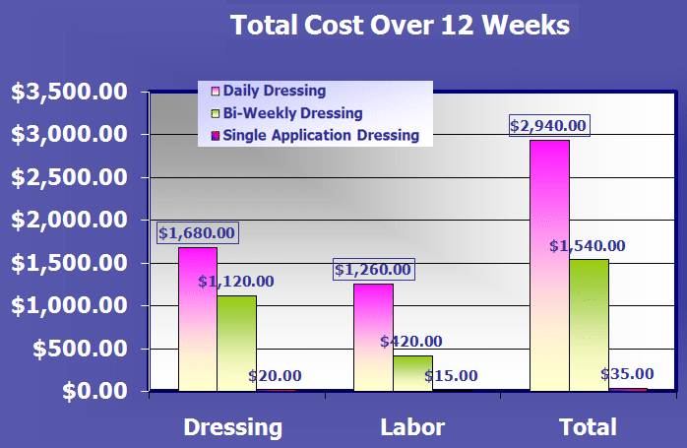
The graph above shows just how much can be saved with implementation of Dermafill dressings into your current wound care practice

